Violations suffered while detained on April 19, 2022 after suffering an assassination/robbery at my premises.

Tortured, dehumanized, sexually abused by Agbor police area command, Delta state police command, asaba, Delta state.

Mouka Emmanuel

January 24, 2023

**Mouka Emmanuel**

**1 MOUKA CLOSE,**

**Beside obison hotel, alihame**

**Agbor, Delta state, Nigeria**

**233 558468957, 233 570464341**

**The executive secretary**

**Through the state coordinator**

**National human rights commission**

**No. 10 Maryam babangida way**

**Asaba, Delta state**

**Introduction**

I am Mouka Emmanuel. I have a Registered business with the cac, neural networks and artificial intelligence ltd, and residence at alihame, Agbor, Delta state, Nigeria. We provide counter-surveillance and security services.. I attend Lancaster university Ghana, the detainment since April 19, 2022 has prevented me from continuing my studies. It has been my desire to join the Nigeria police force in 2021/2022. Unfortunately these challenges reflects the importance of a trained force that respects and upholds the rights of residents of Nigeria.

**Names and contacts of violators**

Violator: Delta state police command, asaba, Delta state, Nigeria

Contact: Delta state police command, asaba, Delta state, Nigeria

Violation: unlawful detainment, extortion, torture, dehumanization,

Name: Officer yakubu, O/C Homicide, Delta state police command, asaba, Delta state, Nigeria.

Contact: OFFICE AT FIRST FLOOR, O/C HOMICIDE, DELTA STATE POLICE COMMAND

Violation: officer yakubu directly coordinated the actions and violations carried out by officer onyeama and blessing.

Name: Officer onyeama, Delta state police command, asaba, Delta state, Nigeria

Contact: 08032645087

Violation:

* Responsible for not taking a factual statement from me, involved in the actions of the investigating officers, onyeama and blessing falsifying a statement with a claim that it would be better for them to falsify a statement a statement because it would be "bailable" rather than taking my factual statement. Officer onyeama did not take action to protect my family from the attacks I suffered during the incident when I was unjustly and unlawfully detained and during incidents of assassination attempts targeted at me and my family at the same residence where I suffered the attack on April 19, 2022, which was verbally dictacted to the police but refused to be taken in writing with a notice that the unlawful act of falsifying a statement was preferred.

Name: Officer blessing, Delta state police command, asaba, Delta state, Nigeria

Contact: 08033902092

Additional info: Bank account, Fidelity bank, Account no. 632183333, account name, blessing edosa, 500,000 naira was sent on JUNE 16, 2022, for the purpose of bail, an initial amount of 500,000 naira was paid at an earlier date. (PHOTO 1)

Violation:

* Responsible for not taking a factual statement from me, involved in the actions of the investigating officers, onyeama and blessing falsifying a statement with a claim that it would be better for them to falsify a statement a statement because it would be "bailable" rather than taking my factual statement. Officer blessing did not take action to protect my family from the attacks I suffered during the incident when I was unjustly and unlawfully detained and during incidents of assassination attempts targeted at me and my family at the same residence where I suffered the attack on April 19, 2022, which was verbally dictacted to the police but refused to be taken in writing with a notice that the unlawful act of falsifying a statement was preferred.

Name: Barr Goodluck kalikul, office reasonably at Agbor.

Contact: 08033488547

Violation:

* Responsible for collaborating with the investigating officers to falsify a statement. Barr.Kalikul and the investigating officers termed the unlawful act of falsifying a statement as "falsifying bailable statement" rather than taking my factual statement.
* Barr.Kalikul received money for provision of healthcare access to me from my personal doctors when he assured me he would take action to resolve the complaints against him and person's involved by me. He did not provide the required service paid for and notified me that the police officer onyeama would like a mental evaluation carried out on me which I protested that only a judge can issue such an order. The basis for such a request may be to prevent justice for the wrong doing, torture, extortion and abuse suffered in their custody. Barr.kalikul took money for privision of my personal doctors but possibly arranged for a doctor identifying himself as "Elliot" to attend to me, I refused to engage the doctor or provide my name when he visited without bar.kalikul to confirm the arrangement I paid 300,000 naira towards and gave a gift of 150,000 naira in addition to ensure barr.kalikul carried out the required action of getting my personal doctors to attend to my affairs. Barr.kalikul may have unlawful carried out the request of office onyeama without a court order to possibly increase my suffering while detained and prevent justice for the abuse targeted at me.
* Information available to me on enquiry into the relationship between Barr.kalikul and all person's involved in the matter revealed he was related to the accusing party. This indicates that Barr.kalikul wrongdoing may be borne of malice towards me. His act of collaborating with the police to falsify a statement may be borne of suspected malice, being related to the accusers from available information. This suspicion renders the falsification by Barr.kalikul and police inadmissible before a court.

Name: Officer duke Amerika, Agbor police area command, Agbor police divisional command

Contact: 08038290149

Violation:

* Responsible for not assisting when I requested his assistance as a police officer that responded to my calls and reports during previous assassination and robberies such as his response on February 12,2022. He is aware that I am detained and continues to provide security to me at my premises on demand to prevent further attacks while detained but did not act on my notice that he inform and assist the police that the complaints of assassination and robbery are factual and that I reported to him earlier with an invitation to my premises such as on February 12, 2022 to help with previous attacks prior to the attack on April 19, 2022.

**What happened ?**

On April 19,2022 I went to Agbor police area command to report a robbery/assassination at my business/premises, at alihame, Agbor, Delta state, Nigeria. I saw myself passing out at the entrance of the Agbor police area command in my vehicle, I was with a light skinned gentleman from the Agbor general hospital, I asked he accompany me to the police station to assist with my complaint as one of the suspected attackers asked I provide help after multiple attackers gained entry into my business/premises with intent to kill me, my family, staff and destroy my property. After regaining consciousness, I drove into the Agbor police area command. I made known my complaints and was asked to notify a gentleman identified as the S.O, I just regained consciousness and decided it was best to go to the counter directly. I do not know why I lost consciousness but the other party in the vehicle was still in the vehicle when I regained consciousness. He was visibly shaken but there was no available evidence to suspect he was responsible for the possible loss of consciousness. He was at the counter and witnessed my efforts to report the attack I suffered but when the DPO as identified by officers became verbally abusive without cause on seeing me, I lost the gentleman. I have not seen him as at January 22, 2023. He works at the general hospital Agbor, Delta state. The DPO started with verbal abuse, ordered I be put in hand-cuffs and encouraged physical abuse which was carried out by person's who are likely officers, they continually punched my head, seized my vehicle and seized my shoes. They paraded me barefooted between the section identified as the CID office, the counter and jail, and the DPO's office. I was taken to an area where an officer identified as Monday told me that he is older than me and as such I should obey his directives. He told me to write an accidental discharge occured. I refused. The officers brought out mobile phones and took action similar to video recording. They said that I am a child and as such I should obey them or face torture. I refused and notified I would not write a false claim or write anything without my lawyer present. They continued their abuse until nighttime. I received a visitor, Barr.Oyinchi, a magistrates court Judge, he is a relative. He notified me he is not practicing as a lawyer. I refused to give a statement at Agbor police area command without a lawyer present. The officers at Agbor police area command were abusive to my family members through the unjust and unlawful detainment, dehumanization and torture. Officer duke Amerika who received and responded to previous reports of robberies and assassination attempts at my premises visited the jail where I was detained at Agbor police area command, he notified me that my protest at being abused, tortured, dehumanized and forced to give a false statement would lead to me being transferred to Abuja. I reminded the officer that he responded to previous assassination and robberies and should notify the Agbor police area command and assist with my immediate release, he left.

On April, 20, 2022, the officers out me in hand-cuffs and asked I enter a white bus with occupants. A group of person's continually threated me and indicated they would shoot me. Inside the white bus, a female occupant seated behind me carried out various forms of abuses, I suffered these abuses through the trip. We arrived at Delta state police command, asaba, Delta state, Nigeria. I was kept in hand-cuffs in the white bus from the time of arrival till nighttime. I was moved at gunpoint inside the Delta state police command, asaba, delta state, in hand-cuffs by a gentleman who later sexually abused me when I requested to pee. He insisted on holding my penis with his hand in a sexually abusive manner even though I protested. I was continually held at gunpoint and moved to an office on the first floor. I was asked to stand behind a line of other person's briefly, then asked to leave the line and move to another office. The office was labelled O/C Homicide. A gentleman identifying himself as the assistant to the O/C Homicide who eventually proved himself to be a liar, Mr.Yakubu, attended to the matter. The same gentleman was later identified as the O/C Homicide, he attended to the issues at various times through the 35 days of unlawful detainment, torture and abuse lasting from April 20, 2022, to may 25, 2022, when I was taken to Agbor magistrates court, alihame, Agbor, Delta state by officer onyeama. The officer yakubu asked me what happened after notifying me that the person seated behind me in the white bus who continually abused me through the trip was accusing me of murder. I gave an account of the incident I experienced on April 19,2022. He asked officer onyeama to take my statement. Officers onyeama and blessing tortured me and took charge of the affairs after I was moved from the O/C Homicide office on the first floor to an office on the ground floor. They tortured me in that office and attempted to take my statement. I refused and requested my lawyer be present before giving a statement. I was taken to the jail at Delta state police command, asaba, where I faced further abuse. On April 21, 2022, I made efforts to get my lawyers from Lagos to attend to the accusation and unlawful detention, torture, dehumanization and abuse. While waiting for my lawyers, an unknown person identifying himself as Barr.Goodluck kalikul was brought by family members whose notice was that they were trying to help, he said he is a lawyer and can help. I gave a verbal account of the attack I suffered. He listened alongside the police officers and against my protest and without my consent decided they would not take my factual statement. Barr.goodluck kalikul and the police officers decided that they would prefer to write a false statement because it would be "bailable". They proceeded to do that while subjecting me to confusing actions. I had not eaten through the unlawful detainment and abuse. I may have lost consciousness while protesting against the falsification of statement by barr.goodluck kalikul and the police officers. My lawyers arrived and I requested they notify the police authorities of the wrongdoing of falsifying a statement by barr.goodluck kalikul and the investigating police officers. The response was that the officers claimed they had submitted the statement falsified by the police officers and barr.goodluck kalikul which they wrote themselves without my input to their senior officers.

I was notified by a family member that attackers came to my premises and attacked the property. I asked they observe the damage, check if the attackers left evidence such as bullet shells or identifying evidence to allow the police or other authorities investigate and arrest the group of person's determined to destroy my life, my family's lives, my business, my staff's lives, and property. They made the observations and took photos of the damages carried out by the attackers. I do not know if anyone was killed during the attacks yet as the police refused to take action towards an investigation or arrest of suspected persons who are reasonably also affiliated with previous attacks targeted at me, my family, staff, business and property. The attack occured while in police custody at the Delta state police command, asaba, Delta state, Nigeria. I put my family, staff and safety of persons trusting their life to me while conducting activities at my premises first, regardless of the police inaction. I made a request that they grante bail, they agreed and requested 1 million naira. I made the payment totalling 1 million naira. I have still not been notified of being bailed as at January 20, 2023. Officers onyeama and blessing, Delta state police command, asaba, Delta state, received the payment. I continued to make efforts to get bail, get the charge dropped and get the police to acknowledge that the charge against me is falsified as a result of the statement being presented being false, not given by me and not reflective of the factual events that occured April 19, 2022 which is that I and my staff, property suffered a robbery and assassination attempt after we closed business activities for the day at 3pm with witnesses available to attest such as my staff who was also exposed to the attack, staff conducting activities at the new development section who also received notice that all activities were done or closed for the day, and text-messages, Whatsapp conversations, available as evidence. The officers at Delta State police command, asaba, Delta state, agreed to act right after pressure from me and other parties with evidence of the actual events being continually presented to them. The officers made a request to me for financial support. I gave a gift of 1 million naira (photo 2) which totals the amount given to the officers to 2 million naira. I am not accounting for gifts such as a mobile phone purchased as a gift to the Delta state police command, asaba, while in their custody to support police operations when I was notified of the officer attending to the matter having a bad mobile device. I AM also not accounting for the perfume bought for the Delta State police command, asaba, Delta state to show low and support for the brave officers who protect the lives and properties of the residents of Delta state, Nigeria. The violation carried out after my continued support was a refusal by the police officers onyeama and blessing to take my factual statement while unlawfully remanded at Agbor prison due to the magistrate judge declaring the remand request "NOT LEGAL" at magistrates court, alihame, agbor, Delta state, Nigeria. Due to the refusal by the officers to take a factual statement, I refused to welcome the investigating officers when I was notified that they visited the Agbor prison. I insist that any audience must involve taking a factual account of what occured to allow the courts and ministry of justice realize that they may unjustly attempt to charge and prosecute the victim being me, Mouka Emmanuel, due to police misconduct and falsification.

**What had been done before now ?**

* Notified lawyers of police falsification and requested to be given the right of providing a statement myself at the Delta state police command while in custody at Delta state police command, asaba, Delta state, Nigeria.
* Notified family members to inform the Delta state police command asaba of falsifications by the investigating police officers. The response received was not understood, the persons I asked to assist engaged the same IPOs during their efforts, the IPOs did not act when notified of the inaccurate nature of their falsification.
* Notified the Delta state attorney general through email, a copy of the facts sheet was attached alongside details of what occured and summaries of challenges faced including the unlawful act of charging me before a court with a falsified statement. I have not received a response from the office of the Delta state attorney general at the ministry of justice, Delta state, Nigeria, on the facts sheet sent to the Delta state attorney general's office.
* Notified media outlet via email, I plan to engage media outlets if persons with negative intentions attempt to prevent the truth being presented to the police, the courts, the persons involved and the public. The truth is attached.
* Notified police officer duke Amerika of the events. Duke Amerika is the officer I reported previous robberies and assassination attempt to.
* Engaged lawyers, persons advertising ability to assist and persons available to me, all parties are presented the facts sheet and encouraged to verify my facts presented. The response has been sympathy at the unjust detainment. Advise, support and assurance of assistance has been to me by all parties engaged.
* Notified barr.ehiedu , a lawyer I consilted in Agbor to prepare a draft for submission. To the ministry of justice. The draft highlights the false charge and false accusation of murder against me. I have not authorized submission of the draft petition as at January 24,2023.

**Prayers**

* Review of my complaints, violations.
* Advise on what I should do.
* Action towards falsified case by the police.
* Redaction of falsified case taken before Agbor magistrates court, alihame, Agbor, Delta state, Nigeria and umunede high court, umunede, Delta state, Nigeria.
* Apology from offending parties
* Release from custody at Agbor correctional center
* Dismissal of false murder charge in light of events experienced on April 19, 2022, being a robbery / assassination attempt.
* Investigation into events threatening my life and family's before April 19, 2022 attack, during and the attack after April 19, 2022, while I was detained at Delta state police command, asaba, Delta state, Nigeria. I can provide suspected person's names, description and supporting evidence.
* Media publicity if encouraged. I planned to involve the media to prevent further abuse while vindicating myself of criminal suspicion on the basis of the case by police being falsified.
* Review of facts sheet v3 attached. The facts of the attacks I suffered including on April 19, 2022 is presented in verifiable form.

**How can you reach me ?**

* I am currently detained at Agbor correctional facility, Agbor, Delta state, Nigeria.
* Arraigned before magistrates court Agbor on may 25, 2022
* Appeared before umunede high court on Nov 21, 2022, January 9, 2022.

**Photo 1 - 500,000 Naira to blessing edosa on JUNE 16, 2022, as second payment completing 1,000,000 naira for bail. Bail has not been granted as a result of this payment as at January 23, 2023.**

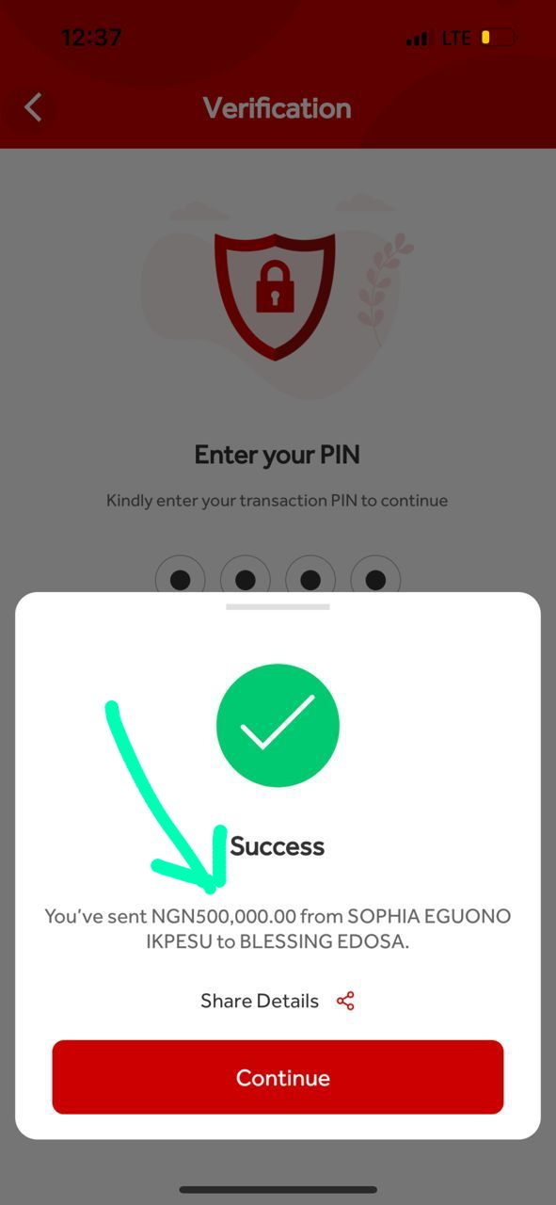

**PHOTO 2 - 1,000,000 naira sent on AUGUST 15, 2022 to officer onyeama on his request for assistance.**

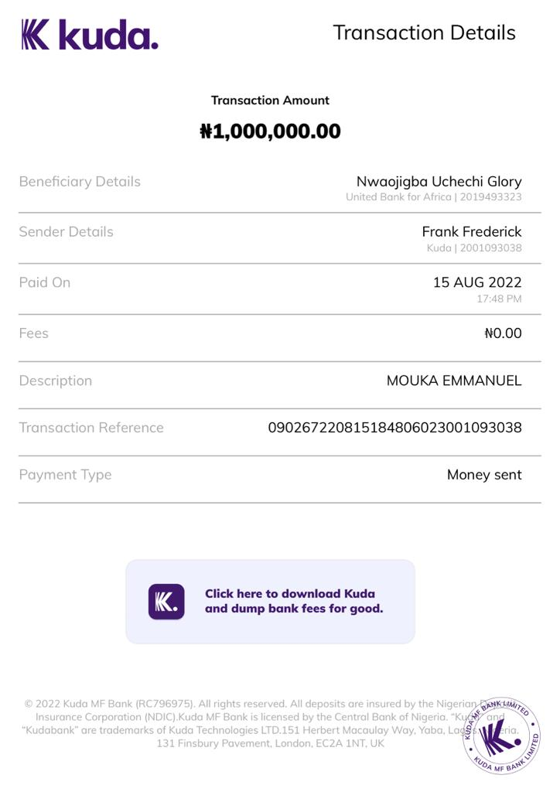

Signed

January 24, 2023

Mouka Emmanuel